Exercise 4 Collection And Exception

Welcome to the Collection And Exception in ASP.NET Core training session on creating a job portal application! This handout provides guidelines for students on how to approach the material, participate in workshops, and complete exercises. The topics covered in this section include Various Collections and Some System Exception and Application Exception and creating Some Custom Exception. Please follow the guidelines below for an optimal learning experience.

Your Exercise will present in Repository .NetCore-Angular-Batch-01 -> .Net_Core-> c-sharp-chapter-3

The Application Look Like as Follows
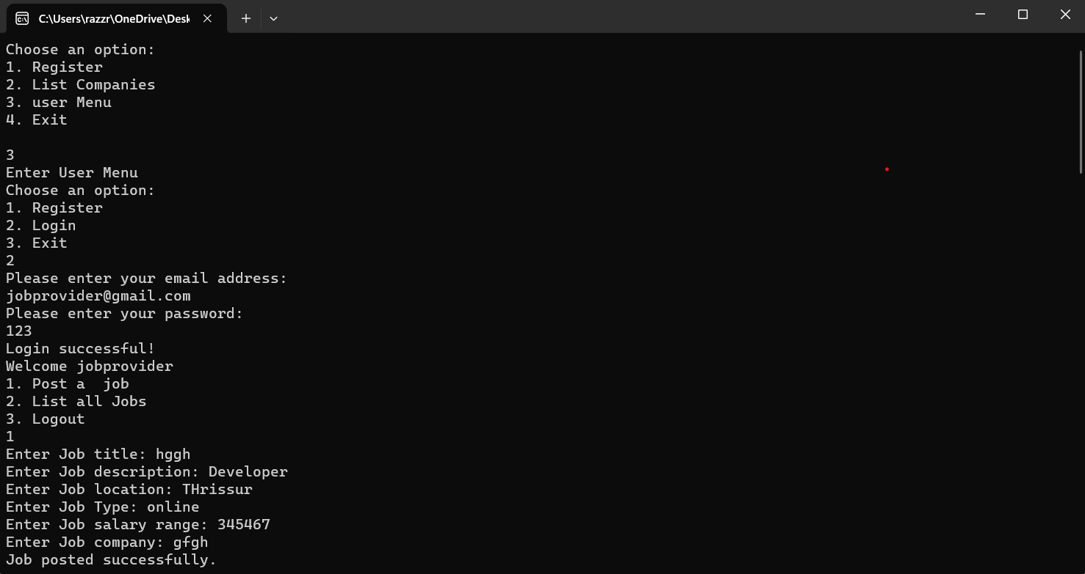

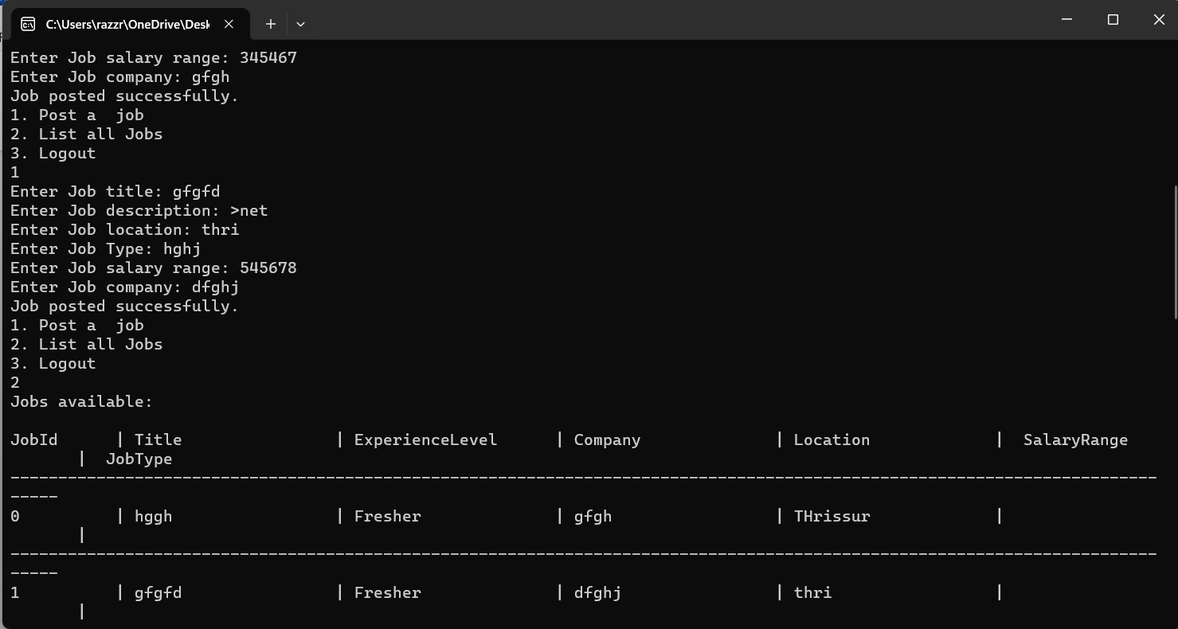

If the Logged User is JobSeeker

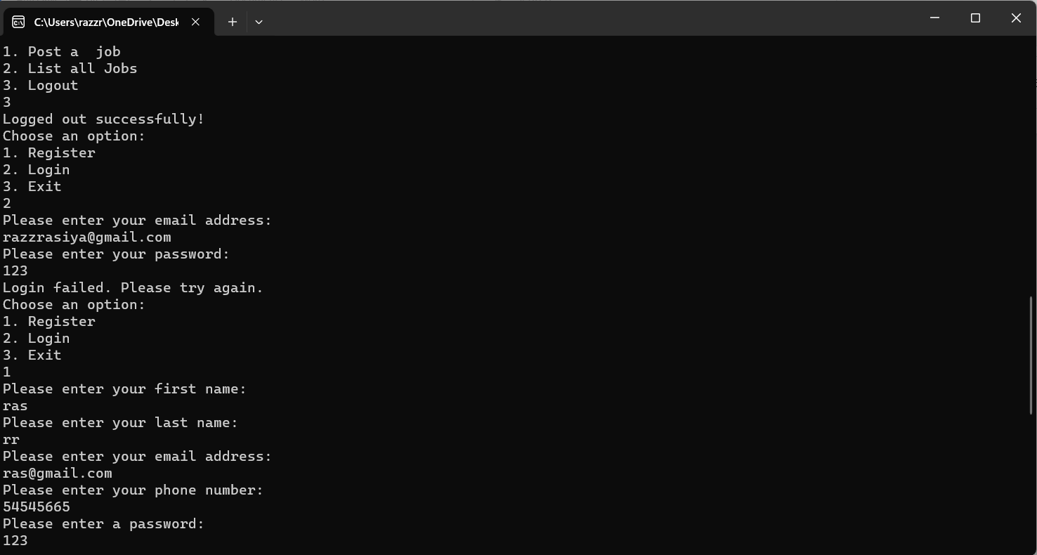
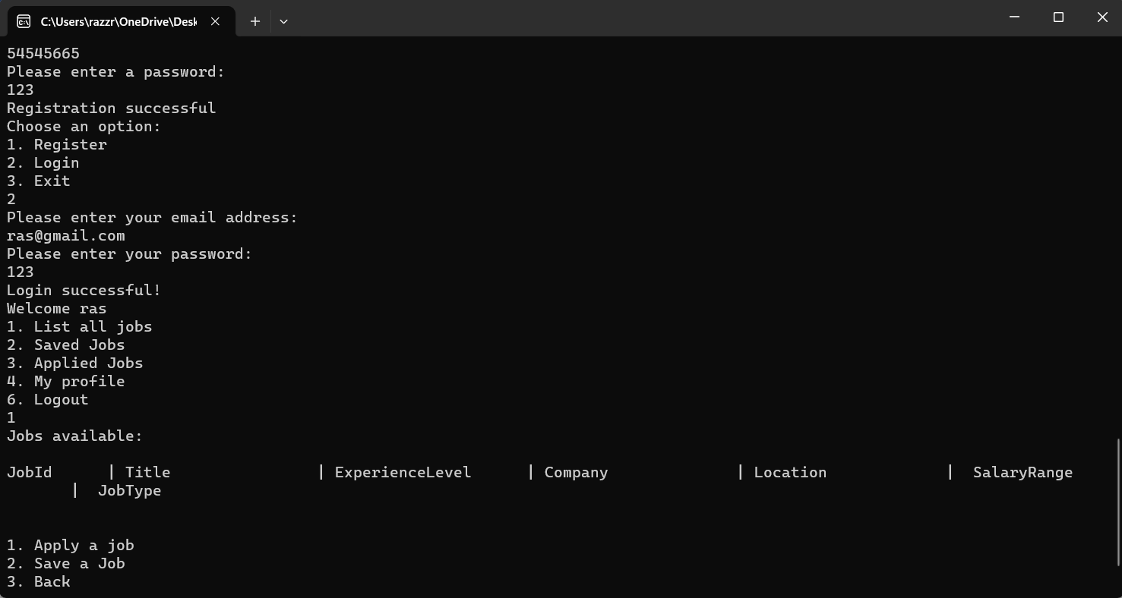
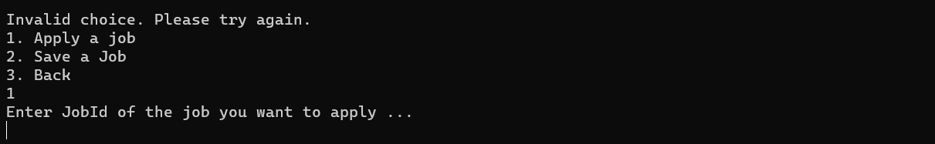

On entering The Job and User added to the applied Jobs List
Note:Use dictionary for applied job list..key as user job list as value

